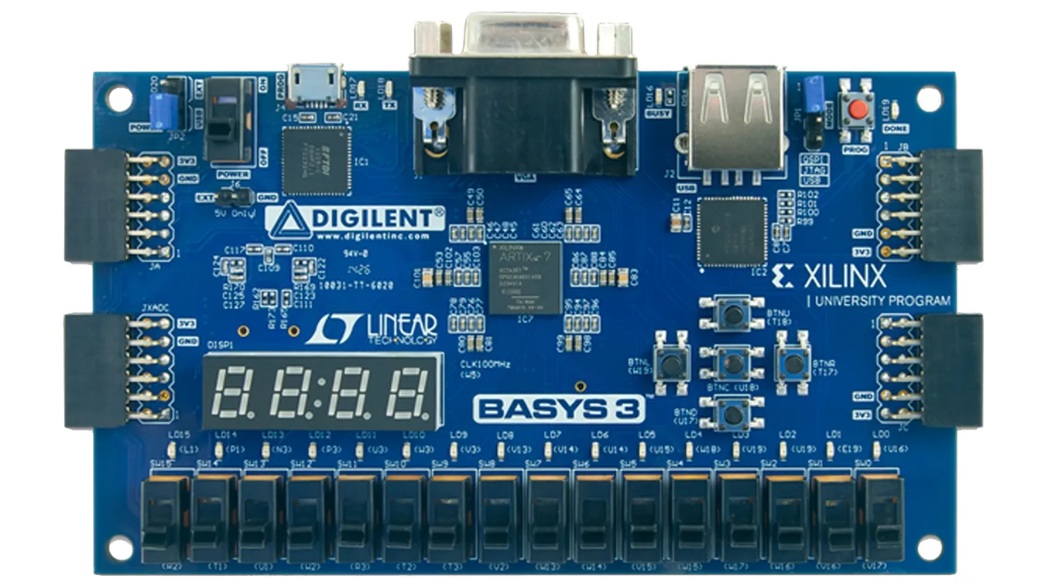

**[0:2] fanspeed**

**[5:0] door_pinLED**

**[2:0] alarm_pinLED**

**idle_reset**

**change**

**room temperature**

**garage door state**

**collision**

**[0:3] desiredSW**

**ONOFF**

**[0:3] outsideSW**

**pin0**

**pin1**

**garage_controller**